**BIOS 6621 HW 01 – R introduction**

Turn in annotated R code and output for the exercises below from the R labs 1-3 posted in the Rstuff folder.  Please submit a Word or PDF file to HW 01 on CANVAS.

Lab 1: Ex 1, 2

> ### BIOS6621 Homework1 Question1

> ### Basic graphing

> x <- c(1,3,4,6,9,10,11,14)

> y1 <- c(102,101,89,92,81,80,75,72)

> y2 <- c(88,85,81,80,76,71,66,64)

> plot( x, y1, xlab = 'x label', ylab = 'y label', pch = 19,

+ type = "b", cex = 0.7, col = "red", lty = 4, lwd = 3,

+ xlim = c(0, 15), ylim = c(60, 110) )

> points( x, y2, pch = "o", cex = 1, col = "blue", lty = 1,

+ type = "b", lwd = 3 )

> ### Ex 1: Add a red horizontal line at mean(y1) and a blue horizontal line at mean(y2)

> abline( h = mean(y1), cex = 0.7, lty = 1, col = "red", lwd = 3)

> abline( h = mean(y2), cex = 0.7, lty = 1, col = "blue", lwd = 3)

> ### Ex 2: Move the legend up on the graph so it looks better and add red and blue points in front of the text

> legend( "topright", leg = c("Female", "Male"),

+ text.col = c("red", "blue"), col = c("red", "blue"),

+ bty = "n", pch = c(19, 111), cex = c(1, 1) )

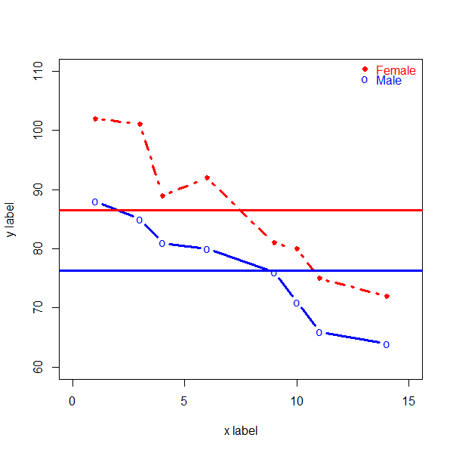

Lab 2: Ex 1, 2, 3

> # Ex 1: Use rep and seq to create c(.2,.2,.4,.4,.6,.6,.2,.2,.4,.4,.6,.6,.2,.2,.4,.4,.6,.6)

> rep( rep( seq( 0.2, 0.6, by = 0.2), each =2), times = 3)

[1] 0.2 0.2 0.4 0.4 0.6 0.6 0.2 0.2 0.4 0.4 0.6 0.6 0.2 0.2 0.4 0.4 0.6 0.6

> # Ex 2: Generate a sample of 10000 normal values with mean 10 and sd 4

> # Make a histogram of the values

> # Check that the empirical mean and SD match those used to generate the sample

> # For X~N(10, 16), find Pr(X > 18)

> # For X~N(10, 16), find the value so that 97.5% of the distribution is less than that value

> # Make a smooth line graph of the N(10, 16) density. (Hint: Use seq)

> set.seed( seed = 5 )

> r.norm <- rnorm( n = 10000, mean = 10, sd = 4 )

> hist( r.norm, xlab = "N(10, 16) sample" )

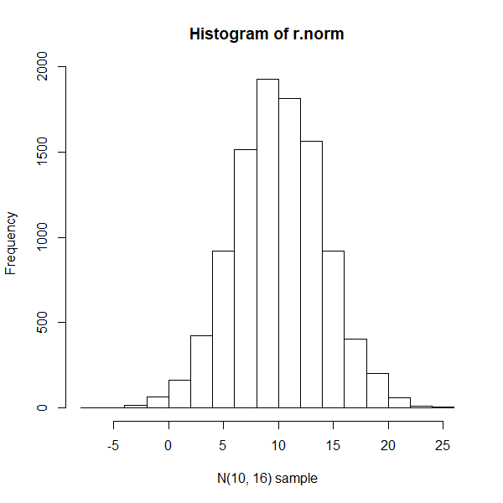

> mean( r.norm ); sd( r.norm );

[1] 10.00724

[1] 4.048991

> p.norm <- pnorm( q = 18, mean = 10, sd = 16 ); p.norm

[1] 0.6914625

> q.norm <- qnorm( p = .975, mean = 10, sd = 4 ); q.norm

[1] 17.83986

> x <- seq( 10 - 4 * 4, 10 + 4 * 4, by = 1 )

> d.norm <- dnorm( x, mean = 10, sd = 4 );

> plot( x, d.norm, xlab = "X-value", ylab = "Probability Density", type = "l")

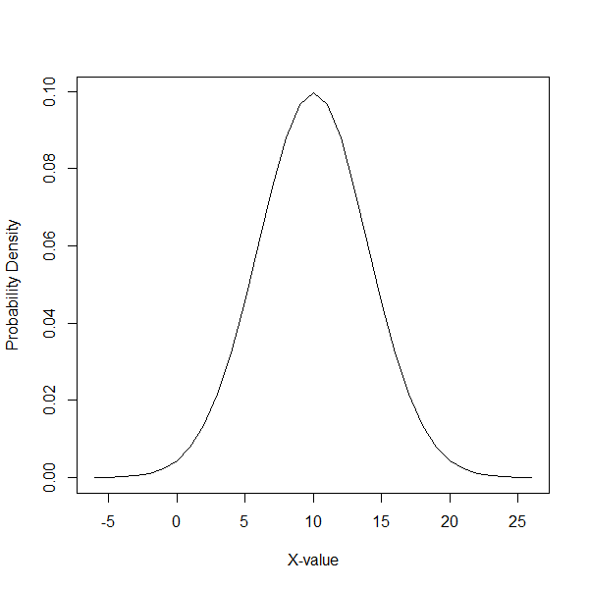

> # Ex 3: Generate a sample of 10000 values from a Gamma distribution with mean 10 and sd 4

> # Verify empirically that your sample mean and sd are close to 10 and 4

> # This is very useful, when working with a new distn in R (or SAS or ...) it's good to do this

> set.seed( seed = 55 )

> mu = 10; sigma = 4

> s <- sigma ^ 2 / mu; a <- mu / s;

> r.gamma <- rgamma( n = 1000, shape = a , scale = s)

> hist( r.gamma, xlab = "Gamma distribution sample")

> mean( r.gamma ); sd( r.gamma );

[1] 10.01178

[1] 4.013219

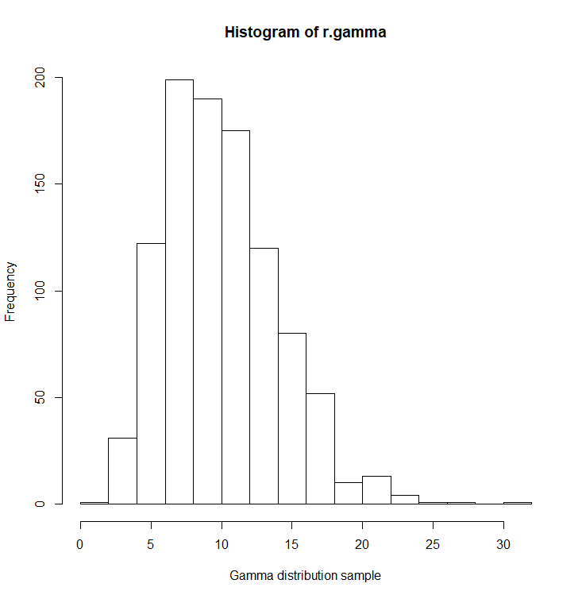

Lab 3: Ex 1, 2, 3

> # Ex 1: Explain (1 sentence each) what each of these statements does

> x[c(3:7)-2]

[1] 1 3 4 6 9

> # to show the values of subset: the element 1 to element 5.

> x[c(3:7)]-2

[1] 2 4 7 8 9

> # to show the values of subset: the element 3 to element 7 minus 2.

> xy.mat[14, ]

> # to show the row 14, the whole columns

> xy.mat[c(2:4)]

[1] 3 4 6

> # to show the row 2, 3, 4, cloumn 1 vaules ( x values)

> cbind(x, lab)

> # to show the column x and column lab together.

> # Ex 2: Using the object xy.mat and not making any new assignments (don't use <-),

> # graph y2 versus x, omitting the 4th row, and with axis labels "y2" and "x"

> x; y

[1] 1 3 4 6 9 10 11 14

[1] 100 101 102 103 104 105 106 107 108 109 110 111

> plot( y2[-4] ~ x[-4], ylab = "y2", xlab = "x" )

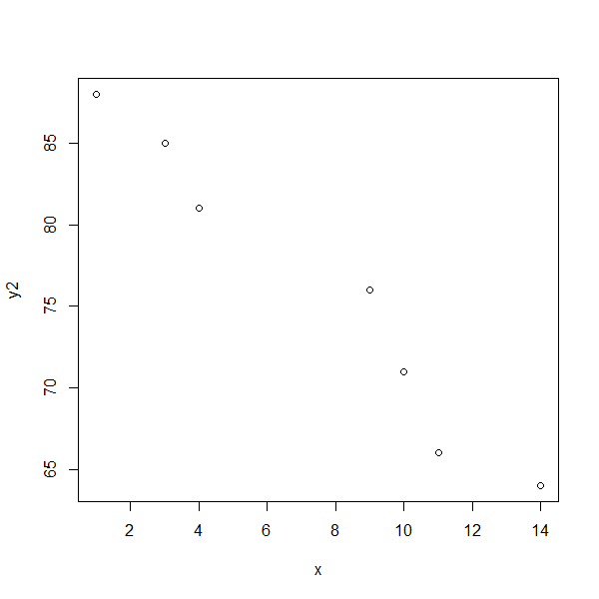

> # Ex 3: Suppose y1 and y2 are measures of an outcome at times 1 and 2 for 8 subjects.

> # So cbind(y1,y2) is the 'wide' form of the dataset

> # Create the 'long' form of the dataset, with 16 rows and 3 columns,

> # a column for y, one for time, and one for subject id.

> y.long <- rbind( c( y1, y2 ) ); y.long

[,1] [,2] [,3] [,4] [,5] [,6] [,7] [,8] [,9] [,10] [,11] [,12] [,13] [,14] [,15] [,16]

[1,] 102 101 89 92 81 80 75 72 88 85 81 80 76 71 66 64

> rownames( y.long ) <- c("y-value"); y.long

[,1] [,2] [,3] [,4] [,5] [,6] [,7] [,8] [,9] [,10] [,11] [,12] [,13] [,14] [,15] [,16]

y-value 102 101 89 92 81 80 75 72 88 85 81 80 76 71 66 64

> y.time <- rep( c( 1, 2 ), each = 8); y.time

[1] 1 1 1 1 1 1 1 1 2 2 2 2 2 2 2 2

> sub.ID <- rep( 1:8, time=2) ; sub.ID

[1] 1 2 3 4 5 6 7 8 1 2 3 4 5 6 7 8

> y.mat <- rbind( sub.ID, y.time, y.long ); y.mat

[,1] [,2] [,3] [,4] [,5] [,6] [,7] [,8] [,9] [,10] [,11] [,12] [,13] [,14] [,15] [,16]

sub.ID 1 2 3 4 5 6 7 8 1 2 3 4 5 6 7 8

y.time 1 1 1 1 1 1 1 1 2 2 2 2 2 2 2 2

y-value 102 101 89 92 81 80 75 72 88 85 81 80 76 71 66 64

> y.mat.t <- t( y.mat ); y.mat.t

sub.ID y.time y-value

[1,] 1 1 102

[2,] 2 1 101

[3,] 3 1 89

[4,] 4 1 92

[5,] 5 1 81

[6,] 6 1 80

[7,] 7 1 75

[8,] 8 1 72

[9,] 1 2 88

[10,] 2 2 85

[11,] 3 2 81

[12,] 4 2 80

[13,] 5 2 76

[14,] 6 2 71

[15,] 7 2 66

[16,] 8 2 64